Read from STDIN, Write to STDOUT | Basics of Input/Output & Basic Programming Practice Problems
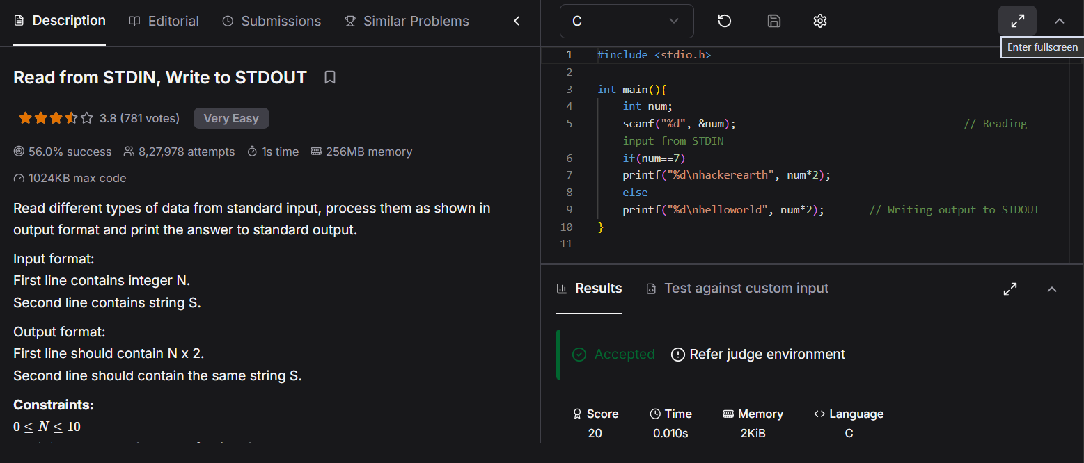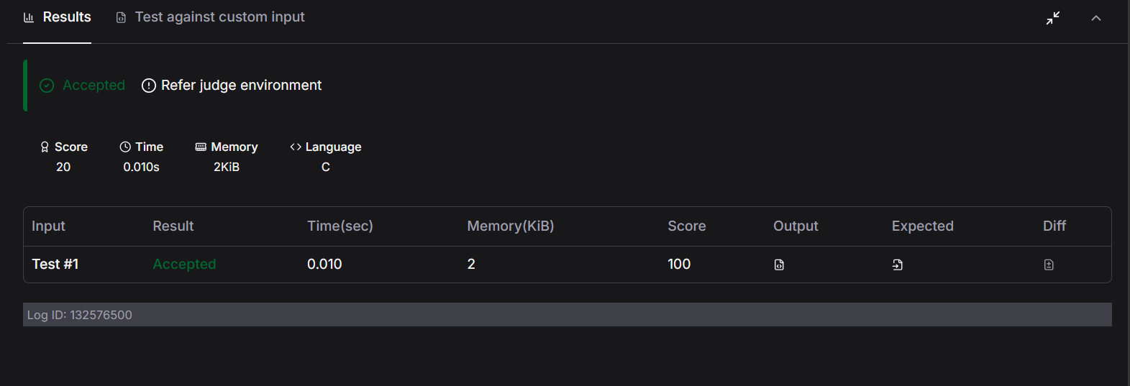#include <stdio.h>

int main(){
int num;
scanf("%d", &num); // Reading input from STDIN
if(num==7)
printf("%d\nhackerearth", num*2);
else
printf("%d\nhelloworld", num*2); // Writing output to STDOUT
}

